**Practical No.8**

**Aim**: Write a program in python to insert watermark in image.

**Softwares Used**: Jupyter Notebook, Opencv

**Environment**: python 3.11.2

**Theory:**

Python is a high-level programming language that is designed to be easy to read and write. Python comes with a large standard library that includes modules for various tasks, such as working with regular expressions, networking, and file I/O. This means that you don't have to write code from scratch for every task, as there's likely a pre-existing module you can use. python is dynamically typed, which means that variables don't need to be declared before they are used, and their types can change at runtime.

OpenCV (Open Source Computer Vision) is an open-source computer vision and machine learning software library. It provides a set of tools and algorithms for image and video processing, machine learning, and computer vision tasks. OpenCV is written in C++, but it also has interfaces for Python, Java, and MATLAB.

**Program Code**:

# import all the libraries

from PIL import Image

from PIL import ImageFont from PIL import ImageDraw import matplotlib.pyplot as plt

import numpy as np

# image opening

image = Image.open("dolphin.jpg")

# this open the photo viewer image.show() plt.imshow(image)

# text Watermark

watermark_image = image.copy()

draw = ImageDraw.Draw(watermark_image)

# ("font type",font size) w, h = image.size x, y = int(w / 2), int(h / 2) if x > y:

font_size = y elif y > x:

font_size = x else: font_size = x

font = ImageFont.truetype("arial.ttf", int(font_size/6))

# add Watermark

# (0,0,0)-black color text

draw.text((x, y), "dolphin", fill=(0, 0, 0), font=font, anchor='ms') plt.subplot(1, 2, 1) plt.title("black text")

plt.imshow(watermark_image)

# add Watermark

# (255,255,255)-White color text

draw.text((x, y), "dolphin", fill=(255, 255, 255), font=font, anchor='ms') plt.subplot(1, 2, 2)

plt.title("white text") plt.imshow(watermark_image)

**Output**:

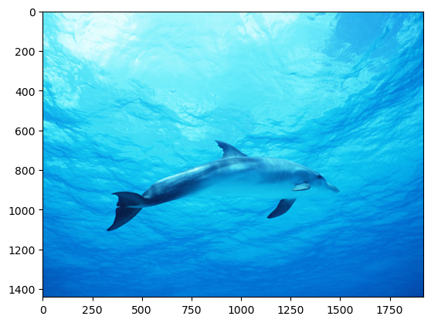 1)Original Image

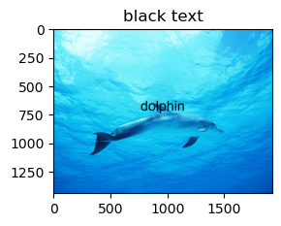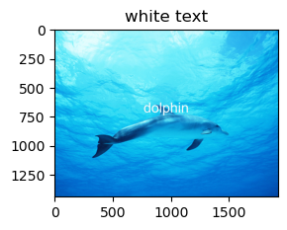 2) White Text and Black Text Watermarked Image

**Conclusion**: In this practical , we successfully study and implement about insert Watermark an image using Python.